# 

BWF Code of Conduct

Fire Risk Assessment Questionnaire

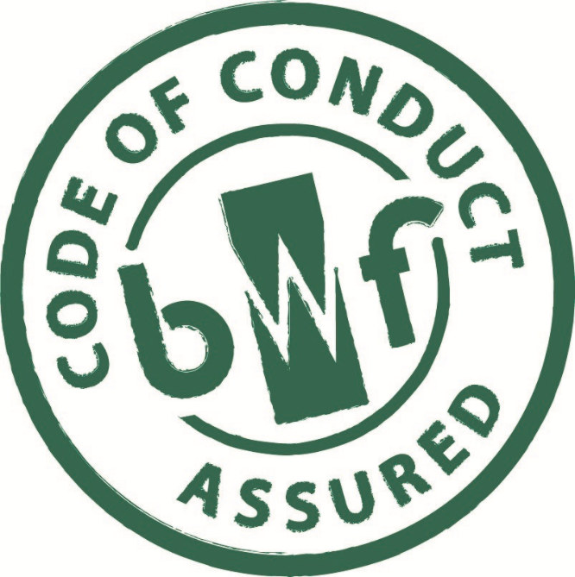

The BWF Code of Conduct aims to provide specifiers, end-users and their suppliers with greater confidence that the Member is working to a set of principles of good practice, set out in this document.

# **The Regulations**

Under the Regulatory Reform (Fire Safety) Order 2005 and Regulation 38 of the building regulations, the contractor is responsible for handing over the correct information to the client (or their appointed representative) or the responsible person. This could vary according to the nature of the building or contract, but a typical recipient could be a Health and Safety or Environmental Health Officer, the client’s surveyor or architect, or the building project manager responsible for the final sign-off of the building contract.

You must ensure that reasonable steps are taken to reduce the risk from fire and ensure that the occupants of the premises can escape safely should a fire break out.

In simple terms, this requires a fire risk assessment to be carried out. The BWF has produced a simple guide to carrying out such a risk assessment Fire *- A simple guide to carrying out a risk assessment which can be downloaded from the Publications Section of the BWF Website* [*www.bwf.org.uk*](http://www.bwf.org.uk)

This additional tool has been designed to highlight those areas within the workplace that could impact of your assessment.

# **Questionnaire**

|  |  |
| --- | --- |
| **Question** | **Complete all boxes Y/N/NA** |
| 1. Is smoking strictly prohibited in all parts of the workplace other than designated smoking areas? |  |
| 2. Are designated smoking areas regularly inspected i.e. at least twice a day? |  |
| 3. Is there a management system for controlling the storage and amount of combustible materials and flammable liquids and gases that are kept in the work place? |  |

|  |  |
| --- | --- |
| 4. Is the system operating correctly? |  |
| 5. Is the workplace free of rubbish and combustible waste materials e.g. off-cuts, shavings? |  |
| 6. Is cooking equipment kept only in separate eating areas? |  |
| 7. Are all heaters fitted with suitable guards and fixed in position away from combustible materials? |  |
| 8. Are all items of portable electrical equipment inspected regularly and labelled as such? |  |
| 9. Are mains electrical flexes run in safe places where they; (a) will not be damaged, and; (b) are not a trip hazard? |  |
| 10. Is the use of extension leads and multi-point adapters kept to a minimum e.g. IT equipment only? |  |
| 11. Are suitable measures in place to protect against the risk of arson? |  |
| 12. Have plans been made and rehearsed regarding assisting disabled staff and visitors (as well as your own workforce) to evacuate the premises? |  |
| 13. Has a fire drill taken place within the last three months? |  |
| 14. Have all staff received suitable fire safety training? |  |
| 15. Can everyone get to a place of relative safety e.g. fire escape stair, within 2-3 minutes? |  |
| 16. Are the internal fire doors labelled as such and normally not wedged open? |  |
| 17. Is there a sufficient number of exits of suitable width for the people likely to be present? |  |
| 18. Do the exits lead to a place of safety? |  |
| 19. Are gangways and escape routes free from obstructions? |  |
| 20. Are the escape routes free from tripping and slipping hazards? |  |
| 21. Are steps and stairs in a good state of repair? |  |
| 22. Are final exits always unlocked when the premises are in use? |  |
| 23. Are the devices securing final exits capable of being opened immediately and easily without the use of a key? |  |
| 24. Are the self-closers on fire doors operating correctly? |  |
| 25. Do the doors on escape routes open in the direction of travel (i.e. towards the escape route)? |  |
| 26. Are escape routes clearly signed? |  |
| 27. Are escape routes adequately lit? |  |
| 28. Do procedures and practices avoid the use of combustible materials or processes that use heat? |  |
| 29. Has consideration been given to all cost effective measures that could be taken to prevent the occurrence of arson? |  |
| 30. Have staff been trained in how to call the fire brigade, use fire extinguishers, basic fire prevention? |  |
| 31. After you have carried out your fire-risk assessment, do you know that you can consult your Fire and Rescue Service who may be able to help you with practical advice or information (See under ‘Fire’ in the phone book). |  |
| 32. Where escape lighting is installed is it in working order and maintained regularly? |  |
| 33. Is there an automatic fire detection and alarm system? |  |
| 34. Is the fire alarm system in good working order? |  |
| 35. Is the fire alarm tested weekly? |  |
| 38. Can the fire alarm be raised without placing anyone in danger? |  |
| 36. Are the fire alarm call points clearly visible and unobstructed? |  |
| 37. Is an adequate number of suitable fire extinguishers provided? |  |
| 38. Are fire extinguishers and fire blankets located suitably and ready for use? |  |
| 39. Have the fire extinguishers been serviced in the past 12 months? |  |
| 40. Are electrical appliances unplugged at night? |  |
| 41. Is any fixed fire-fighting installation or automatic fire detection system in working order? |  |
| 42. Have you told your staff or their representatives about the need for vigilance and to eliminate the risk of fire? |  |
| 43. If the workplace is shared with others have you sought their co-operation in reducing the fire risk? |  |
| 44. Has any work been identified by this assessment and has it been made known to those responsible for the upkeep of the workplace? |  |
| 45. Are fire action notices displayed prominently throughout the workplace? |  |
| 46. Has an emergency plan been drawn up in case of a major fire? |  |
| 47. Is a copy of the emergency plan kept other than at the workplace? |  |

# **Dangerous Materials/Processes**

|  |  |
| --- | --- |
|  | Yes/No |
| 48. Are dangerous materials stored on site e.g. explosive substances, inflammable liquids or chemicals? |  |
| 49. Do you have a site map or building plan showing the location of these materials? |  |
| 50. Are flame or spark producing appliances in use? |  |