# 

BWF Code of Conduct

Fire – A Simple Guide to Carrying out a Risk Assessment

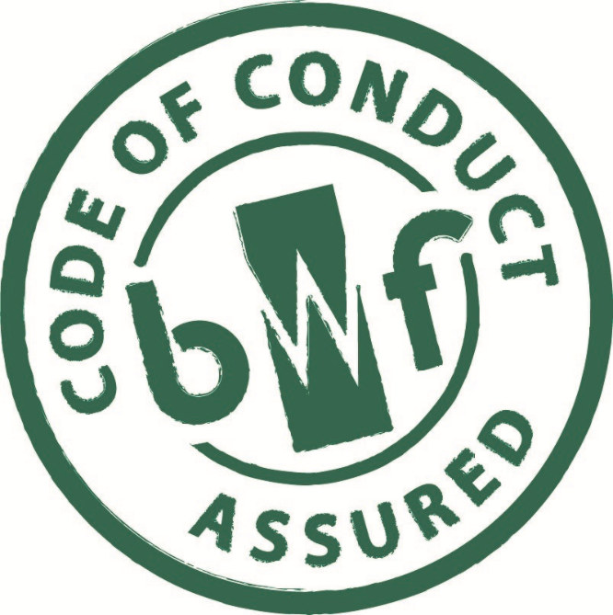

The BWF Code of Conduct aims to provide specifiers, end-users and their suppliers with greater confidence that the Member is working to a set of principles of good practice, set out in this document.

# **The Regulations**

Under the Regulatory Reform (Fire Safety) Order 2005 and Regulation 38 of the building regulations, the contractor is responsible for handing over the correct information to the client (or their appointed representative) or the responsible person. This could vary according to the nature of the building or contract, but a typical recipient could be a Health and Safety or Environmental Health Officer, the client’s surveyor or architect, or the building project manager responsible for the final sign-off of the building contract.

You’re responsible for fire safety in business or other non-domestic premises if you’re an employer, the owner, the landlord, an occupier or anyone else with control of the premises. If there’s more than one ‘responsible person’, you have to work together to meet your responsibilities.

You must ensure that reasonable steps are taken to reduce the risk from fire and ensure that the occupants of the premises can escape safely should a fire break out. In simple terms, this requires a fire risk assessment to be carried out.

# **2.0 What is Risk Assessment?**

It is an organised look at what, in your work activities and workplace, could cause harm to people. This will allow you to weigh up whether you have taken enough precautions or should do more to avoid harm. The important things you need to decide are whether a hazard is significant and whether you have covered it by satisfactory precautions so that the risk is acceptably low.

**What do the terms 'hazard' and 'risk' mean?**

* A hazard is something that has the potential to cause harm.
* A risk is the chance, high or low, of that harm occurring.

**Before you start your risk assessment**

Check whether any of the fire safety arrangements in your workplace have previously been approved under other fire safety, licensing or building legislation. If this is the case, an assessment of the fire precautions needed under that legislation would have been made at the time by, or in consultation with, the fire authority or the building control authority.

Regardless of any previous approval, you still need to carry out a fire risk assessment. However, if the previous approval covered all the matters required by the Fire Regulations, and conditions have remained unchanged, e.g. numbers of people present, work activity etc, then your fire risk assessment may well show that few, if any, additional precautions are needed.

Your risk assessment may identify additional matters which need addressing if the previous approval was given according to an out-of-date standard of fire precautions, or the approval was under legislation which does not cover all the requirements of the Fire Regulations. If you are not sure, your local fire authority will be able to advise you.

# **2.0 How do you do a Fire Risk Assessment?**

# A fire risk assessment will help you determine the chances of a fire occurring and the dangers from fire that your workplace poses for the people who use it. Joinery companies already have to carry out risks assessments for their machinery and working environments as part of their responsibilities to ensure health and safety in the workplace. The assessment method suggested shares the same approach.

# Before attempting to start an assessment take time to prepare. A risk assessment is not a theoretical exercise. However, much work can be done on paper from the knowledge you, your employees or their representatives have of the workplace. A tour of the workplace will be needed to confirm, amend or add detail to your initial views.

**For fire risk assessments there are five steps that you need to take:**

• **Step 1** Identify potential fire hazards in the workplace.

• **Step 2** Decide who (e.g. employees, visitors) might be in danger, in the event of a fire, in the workplace or while trying to escape from it, and note their location.

• **Step 3** Evaluate the risks arising from the hazards and decide whether your existing fire

• **Step 4** Record your findings and details of the action you took as a result. Tell your employees about your findings.

• **Step 5** Keep the assessment under review and revise it when necessary.

Nobody knows as much about your business as you and the people who work with and for you. Try to use your own knowledge and experience and that of your colleagues and staff. Talk to your employees and listen to their concerns. The safety representative (if there is one) and your employees will have a valuable contribution to make. They can help you identify key issues and may already have practical suggestions for improvements.

Proper planning of your assessment, and any changes necessary because of it, includes consulting the workforce and their representatives. This can help ensure that any changes are introduced more easily and accepted more readily. However, remember that risk assessment is essentially a matter of applying informed common sense. You need to identify what could reasonably be expected to cause danger. Ignore the trivial and concentrate on significant hazards.

It is important that you carry out your fire risk assessment in a practical and systematic way. It must take the whole of the workplace into account, including outdoor locations and any rooms and areas which are rarely used. If your workplace is small you may be able to assess the workplace as a whole. In larger buildings, you will often find it helpful to divide the workplace into rooms or a series of assessment areas using natural boundaries, e.g. process areas, offices, stores, workshops as well as corridors, stairways and external routes

If your workplace is in a building shared with other employers, you and all the other occupiers and any other person who has control of any other part of the workplace will need to discuss your risk assessments. This will help to ensure that any areas of higher risk, and the need for any extra precautions, are identified.

# **3.0 After you have completed your Risk Assessment**

If you know, or think, that your workplace is subject to a fire certification or licensing regime, as well as the Fire Regulations, you will need to check that any changes you propose as a result of your risk assessment will not conflict with this other regime. You need to do this before making any changes. In these cases you should consult the local fire authority. They will consider your proposals and advise you if they are acceptable. They will also advise you if any other legislative approvals have to be obtained. For instance, if you propose structural alteration or material change of use (in Scotland, any changes) to a building, approval under relevant building legislation will be required. You must keep a written record of your fire risk assessment if your business has 5 or more people.

|  |  |  |
| --- | --- | --- |
| **Employer starts to assess fire safety in workplace** | | |
| **Employer appoints person to carry out assessment** | | |
| **Plan and prepare for carrying out assessment** | | |
|  | ⇩ |  |
| **STEP** | **ACTIVITY** | **ACTION** |
|  | ⇩ |  |
| **Step 1** | Identify fire hazard |  |
| - sources of ignition |
| - sources of fuel |
| - work processes |
|  | ⇩ |  |
| **Step 2** | Identify the location of people at significant risk in case of fire |  |
|  | ⇩ |  |
| **Step 3** | Evaluate the risks |  |
| Are existing fire safety measures adequate? |
| - control of ignition sources/sources of fuel |
| - fire detection/warning |
| - means of escape |
| - means of fighting fire |
| - maintenance and testing of fire precautions |
| - fire safety training of employees |
| Carry out any improvements needed |
|  | ⇩ |  |
| **Step 4** | Record findings and action taken |  |
| Prepare emergency plan. |
| Inform, instruct and train employees in fire precautions |
|  | ⇩ |  |
| **Step 5** | Keep assessment under review |  |
| Revise if situation changes |

Further Information

Fire Risk Assessment Questionnaire – an additional tool to highlight those areas or activities within the workplace that could impact on your assess.

The main elements of the fire safety regime are set out on the ‘Fire Safety in the Workplace’ pages of the Government’s website (www.gov.uk), which includes an online self-assessment form to help you judge how close you are to compliance.

The Government has also published a range of guidance, including a short explanatory leaflet and more detailed and substantial guides for a variety of types of premises, including factories and workshops – guidance that is available free to download from the ‘Make your premises safe from fire’ pages of the Government website.

The Passive Fire Protection Federation and the Fire Protection Association, which represents the active fire safety industry, have both produced guides to help people through the risk assessment process, which are available on their respective websites (www.pfpf.org and www.thefpa.co.uk).

If Members have any queries or require further guidance on this topic please contact the BWF on 0207 637 2646 or by email on technical@bwf.org.uk.