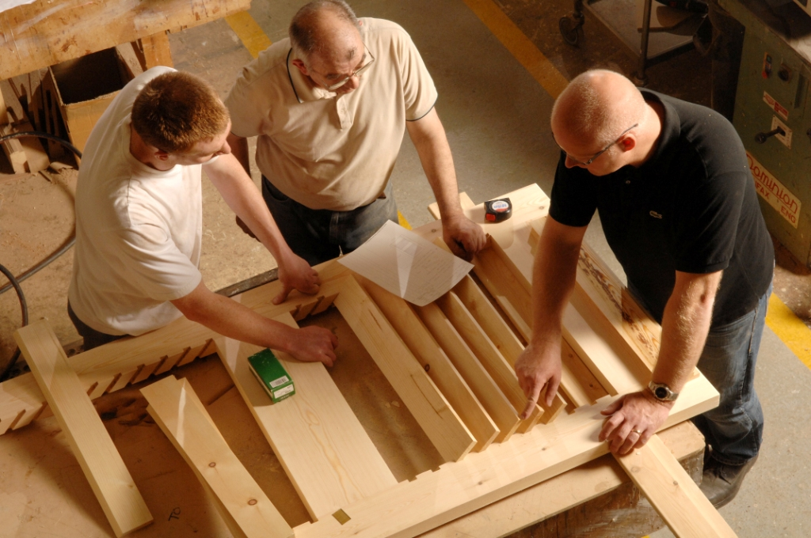

Corporate Social Responsibility Policy

Template policy for members



© 2017 British Woodworking Federation



Corporate Social Responsibility Policy

The company recognises that we must integrate our business values and operations to meet the expectations of our stakeholders. They include customers, employees, regulators, investors, suppliers, the community and the environment.

We recognise that our social, economic and environmental responsibilities to these stakeholders are integral to our business. We aim to demonstrate these responsibilities through our actions and within our corporate policies.

We take seriously all feedback that we receive from our stakeholders and, where possible, maintain open dialogue to ensure that we fulfill the requirements outlined within this policy.

We shall be open and honest in communicating our strategies, targets, performance and governance to our stakeholders in our continual commitment to sustainable development.

The ADD NAME is responsible for the implementation of this policy and will work with our stakeholders to make the necessary resources available to realise our corporate responsibilities. The responsibility for our performance to this policy rests with all employees throughout the company.

**Specifically:**

* We shall strive to improve our environmental performance wherever possible
* We shall ensure a high level of business performance while minimising and effectively managing risk
* We are committed to meeting the Investors in People Standard
* Through effective partnerships, we shall continue our initiatives on efficiency, health & safety, education and environmental improvement within the industry
* We shall encourage dialogue with other bodies for mutual benefit
* We shall operate an equal opportunities policy for all present and potential future employees
* We will offer our employees clear and fair terms of employment and provide resources to enable their continual development
* We shall maintain a clear and fair employee remuneration policy and shall maintain forums for employee consultation and business involvement
* We shall provide safeguards to ensure that all employees are treated with respect and without sexual, physical or mental harassment
* We shall provide, and strive to maintain, a clean, healthy and safe working environment
* We shall uphold the values of honesty, partnership and fairness in our relationships with stakeholders
* Our contracts will clearly set out the agreed terms, conditions and the basis of our relationship
* We will operate in a way that safeguards against unfair business practices
* We shall encourage suppliers and contractors to adopt responsible business policies and practices for mutual benefit

*Note: Whilst every effort has been made to ensure the accuracy of advice given, the BWF cannot accept liability for loss or damage arising from the use of the information supplied in this publication.*

© BWF 2017 (British Woodworking Federation) March 2017