BWF WOODWORKING MACHINERY SAFETY CARD NO 29 |  | 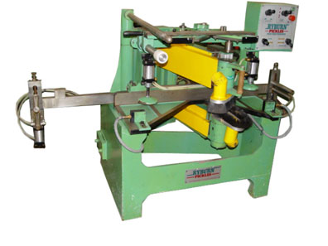 |  | PLANING, MOULDING & PROFILING MACHINES  Stair Trencher  v1 – 2012 © BWF / DIDAC
BWF WOODWORKING MACHINERY SAFETY CARD NO 29 |  | ONLY TRAINED AND AUTHORISED PERSONS TO USE THIS MACHINE  - Use machine to produce stair components - strings
BWF WOODWORKING MACHINERY SAFETY CARD NO 29 |  | SAFE USE PROCEDURES
BWF WOODWORKING MACHINERY SAFETY CARD NO 29 |  | - Fit and properly adjust all guards and safety devices that are applicable to the machine  - Immediately report any machinery defects to your supervisor  - Ensure that air pressure is set correctly  - Ensure that table clamps are set correctly and used to suit component  - Ensure correct depth of cut is set  - Ensure template is secure  - Ensure your hands are clear of the cutters at all times whilst the machine is in motion  - Do not leave the machine unattended whilst in motion  - Report any faults with the machine, guards or dust extraction to your supervisor immediately  - Ensure correct use of Local Extraction Ventilation system  - Ensure the working area around the machine is kept clear at all times  - Use all personal protective equipment (PPE) provided by your employer (e.g. hearing defenders etc)
BWF WOODWORKING MACHINERY SAFETY CARD NO 29 |  | MACHINE MAINTENANCE & CLEANING
BWF WOODWORKING MACHINERY SAFETY CARD NO 29 |  | - DO NOT clean machine whilst still in motion  - Ensure all maintenance is carried out following the machine manufacturer’s instructions
BWF WOODWORKING MACHINERY SAFETY CARD NO 29 |  |  | This is one of a series of guides printed by the BWF.  Further copies are available from British Woodworking Federation  Tel: 0844 209 2610 Fax: 0844 209 2611  e-mail: bwf@bwf.org.uk |  |  | 
ABOUT THE BWF

The BWF currently has over 500 members drawn from manufacturers, distributors and installers of timber doors, windows, conservatories, staircases and all forms of architectural joinery including shopfitting, timber frame buildings and engineered timber components, as well as suppliers to the industry. The turnover of the BWF Membership is estimated to be in around £1 billion

As well as representing and promoting the industry, the BWF offers its membership a range of free comprehensive and tailored services including specialist technical, legal, employment, health & safety, environmental and other business related advice, and a range of resources through our website. Members also receive heavily discounted rates for chain of custody, ISO9000 & ISO14000 certification, health & safety audits, insurance, technical consultancy, window energy ratings, product testing and other useful services.

If you would like more information on membership or how to join, please contact the BWF on 0844 209 2610 or visit our website: www.bwf.org.uk

ABOUT THE  WITFORUM | 
The Woodworking Industry Training Forum is the BWF’s campaign to improve training provision for the woodworking industry. The Forum has four simple aims:
- To provide for members to express their training needs and have a stake in their own future
- To increase the provision of woodworking and joinery skills training
- To help trainers provide their students with the skills the industry needs
- To promote woodworking as a career.

The WITForum offers a range of subsidised training opportunities for members including management & supervisory, health & safety, estimating, and many more. The Forum can also offer advice on funding and other training opportunities for you and your staff.

If you are a BWF member, you become part of the WITForum for free, or you can join separately for a minimal annual fee and take advantage of its courses and other resources. For more information on the WITForum or how to join, please call 0844 815 9981 or visit the website: www.bwf.org.uk/training


Produced by Didac Limited – www.didac.co.uk

